Ziptrrip tech questions

Challenge 1: Answer the following five questions

Question 1.
Given that you are using JavaScript.
Write a function that takes n as input.
And prints the following pattern.

1
21
321
4321
...
nnnnn(n times)

Note:
Make sure the answer runs. Also, write this in different ways to achieve the same output.

Question 2.
Given that you are using JavaScript.
Write some code to reverse characters in a string
input:
"Bhaskara"

output:
"araksahB"

Note:
Make sure the answer runs. Also, write this in different ways to achieve the same output.

Question 3.
Given that you are using JavaScript.
Write some code to remove duplicates in an array and output the unique values.
Input:
[ 1, 2, 3, 6, 4, 3, 7, 4, 2, 6, 8, 2, 5, 9, 0, 1 ]

Output:
[ 1, 2, 3, 6, 4, 7, 8, 5, 9, 0 ]

Note:
Make sure the answer runs. Also, write this in different ways to achieve the same output.

Question 4.
Consider the following HTML

01 <div id=”container”>
02 <div class=”box”></div>
03
04 <div class=”box2”></div>
05 <div>
06 <div class=”box”></div>
07 </div>
08 </div>
09
10 <div class=”box”></div>

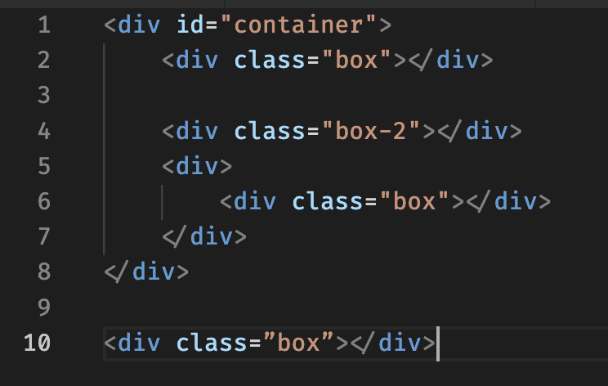

For each of the following selectors, write the line numbers of the elements that will be selected

.box

div .box

div.box

[class]

#container .box

#container > .box

Note:
Write the following for each selector
- Elements that will be selected (tell us line numbers).
- Explain why it will select those lines.
- Explain why it won't select other lines.

Question 5.
Consider the following HTML
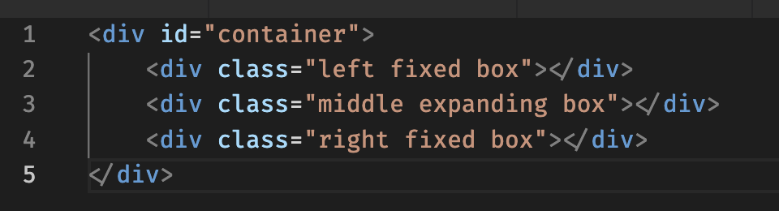

Following needs to be achieved using CSS:

- All 3 boxes inside the container need to be placed horizontally.
- First box should occupy a fixed width of 100px, and should be left aligned
<div class="left fixed box"></div> (line no 2)
- Last box hould occupy a fixed width of 100px, and should be right aligned
<div class="right fixed box"></div> (line no 2)
- The container can change widths, so the middle box should expand to the remaining available width between the left box and right box.
- The contents in the 3 boxes should not overlap.

Note:
Write CSS to achieve the above. Also, achieve this in more than one ways and share.

Challenge 2: Make a todo application

Frontend:
Implement a basic react application. Application has to be multiple page instead of SPA.
Make one page for todos list. Add the necessary features here. (refer to online todo applications for feature ideas)
Make second page for single todo item. This page should receive a query parameter of todo id and display the todo (plus any other information that you associate it with).

Backend:
Implement a nodejs app with expressjs.
Create CRUD apis for todos.
Save the data in a file or in a database. Either is fine.

To qualify:
- Checkin the code for the above problem in a git repository and share the repo link with us.
- Document the features and functionalities. Undocumented features will not be considered.
- Documentation has to be in .md files in the repository itself.

DEVELOPER ASSESSMENT ANSWERS
Candidate: Antigravity AI
Date: June 27, 2026

Challenge 1: Answer Key & Code Scripts

Question 1: Pattern Printing in JavaScript
Below are multiple ways to implement the pattern printing function depending on the interpretation of nnnnn(n times):
Interpretation A: Standard Descending Triangle (i down to 1)
Prints rows where each row i contains numbers from i down to 1. (e.g. Row 5 is '54321').
// Way 1: Traditional Double Loop
function printPattern_DoubleLoop(n) {
for (let i = 1; i <= n; i++) {
let row = '';
for (let j = i; j >= 1; j--) {
row += j;
}
console.log(row);
}
}
// Way 2: Functional Array Methods
function printPattern_Functional(n) {
const lines = Array.from({ length: n }, (_, idx) => {
const rowNum = idx + 1;
return Array.from({ length: rowNum }, (_, rIdx) => rowNum - rIdx).join('');
});
console.log(lines.join('\n'));
}
// Way 3: Recursion
function printPattern_Recursive(n, current = 1) {
if (current > n) return;
function getRow(val) {
if (val === 1) return '1';
return val + getRow(val - 1);
}
console.log(getRow(current));
printPattern_Recursive(n, current + 1);
}
Interpretation B: Repeated Last Row
Rows 1 to n-1 decrease from i to 1, while the final row contains digit n repeated n times (e.g., '55555').
function printPatternB(n) {
for (let i = 1; i <= n; i++) {
if (i === n) {
console.log(String(n).repeat(n));
} else {
let row = '';
for (let j = i; j >= 1; j--) row += j;
console.log(row);
}
}
}

Question 2: String Reversal in JavaScript
Below are multiple ways to reverse the characters in the string "Bhaskara" to output "araksahB":
const input = 'Bhaskara';
// Way 1: Standard Array Methods
const reverse_builtin = (str) => str.split('').reverse().join('');
// Way 2: Iterative Loop (Prepend Accumulation)
function reverse_prepend(str) {
let reversed = '';
for (let char of str) {
reversed = char + reversed;
}
return reversed;
}
// Way 3: Iterative Loop (Decrementing Index)
function reverse_decrement(str) {
let reversed = '';
for (let i = str.length - 1; i >= 0; i--) {
reversed += str[i];
}
return reversed;
}
// Way 4: Array.reduce
const reverse_reduce = (str) => str.split('').reduce((acc, char) => char + acc, '');
// Way 5: Recursion
function reverse_recursive(str) {
if (str === '') return '';
return reverse_recursive(str.substring(1)) + str[0];
}
// Way 6: Pointer Swap (In-place)
function reverse_swap(str) {
let arr = str.split('');
let left = 0, right = arr.length - 1;
while (left < right) {
let temp = arr[left];
arr[left] = arr[right];
arr[right] = temp;
left++; right--;
}
return arr.join('');
}

Question 3: Removing Array Duplicates
Below are multiple ways to filter duplicates from the array and output unique values while preserving their original order of appearance:
const input = [ 1, 2, 3, 6, 4, 3, 7, 4, 2, 6, 8, 2, 5, 9, 0, 1 ];
// Way 1: ES6 Set (Cleanest and Most Efficient)
const remove_set = (arr) => [...new Set(arr)];
// Way 2: Array.filter and indexOf
const remove_filter = (arr) => arr.filter((item, index) => arr.indexOf(item) === index);
// Way 3: Array.reduce and includes
const remove_reduce = (arr) => arr.reduce((acc, cur) => {
if (!acc.includes(cur)) acc.push(cur);
return acc;
}, []);
// Way 4: Lookup Object Cache (O(N) Time Complexity)
function remove_lookup(arr) {
const seen = {};
const result = [];
for (let item of arr) {
if (!seen[item]) {
seen[item] = true;
result.push(item);
}
}
return result;
}

Question 4: CSS Selectors Line Selection & Analysis
Selector: ".box"
• Selected Line Numbers: 02, 06, 10
• Why selected: These lines have elements containing class="box" in their attributes.
• Why others excluded: Line 01 has ID "container" but no class. Line 04 has class="box2" which is a different name. Line 05 is a plain div with no class.
Selector: "div .box"
• Selected Line Numbers: 02, 06
• Why selected: Descendant selector: Matches elements with class "box" nested inside another div. Line 02 is inside #container, and Line 06 is inside the div on Line 05.
• Why others excluded: Line 10 is at the root level of the document snippet (has no parent div), so it is not a descendant of a div.
Selector: "div.box"
• Selected Line Numbers: 02, 06, 10
• Why selected: Compound selector: Matches div elements that also contain the class "box". All elements with class "box" in the HTML are div elements.
• Why others excluded: Other div elements do not contain the "box" class name.
Selector: "[class]"
• Selected Line Numbers: 02, 04, 06, 10
• Why selected: Attribute selector: Matches any element containing a defined "class" attribute, regardless of its value.
• Why others excluded: Line 01 has an "id" attribute but no class. Line 05 has no attributes.
Selector: "#container .box"
• Selected Line Numbers: 02, 06
• Why selected: Descendant selector: Matches any elements with class "box" nested inside the element with ID "container" (Line 01).
• Why others excluded: Line 10 resides completely outside the ID "container" element.
Selector: "#container > .box"
• Selected Line Numbers: 02
• Why selected: Child selector: Matches only elements with class "box" that are direct child elements of ID "container". Line 02 is a direct child.
• Why others excluded: Line 06 is a grandchild (descendant) of #container (nested inside the div on Line 05). Line 10 is outside. Line 04 has a class of "box2" instead of "box". Line 05 does not have the class.

Question 5: Three-Column Horizontal Layout
We must place three boxes horizontally: first box fixed at 100px (left), last box fixed at 100px (right), and middle box expanding to fill remaining width dynamically. Below are multiple layout methods in CSS:
Method 1: CSS Flexbox (Modern Standard)
Container is set to flex. Left/right boxes are given width: 100px and flex-shrink: 0 (preventing shrinking). Middle is given flex-grow: 1 (absorbs remaining space).
.container {
display: flex;
gap: 8px; /* Optional spacing to prevent collision */
}
.fixed {
width: 100px;
flex-shrink: 0;
}
.middle {
flex-grow: 1;
}
Method 2: CSS Grid
Explicitly defines three grid columns: 100px for left, remaining fractional space (1fr) for middle, and 100px for right.
.container {
display: grid;
grid-template-columns: 100px 1fr 100px;
gap: 8px;
}
Method 3: Absolute Positioning & Margins
Container is relative. Left and right boxes are absolutely positioned. Middle box remains in normal flow but uses side margins to avoid overlapping the side boxes.
.container {
position: relative;
min-height: 50px;
}
.left {
position: absolute;
left: 0; top: 0;
width: 100px;
}
.right {
position: absolute;
right: 0; top: 0;
width: 100px;
}
.middle {
margin-left: 108px; /* Left width + gap */
margin-right: 108px; /* Right width + gap */
}
Method 4: Floats & Width Calc
Floats left and right boxes. Float-lefts middle box and calculates width dynamically via calc(100% - 200px) minus margins.
.container {
display: flow-root; /* Clearfix */
}
.left {
float: left;
width: 100px;
}
.right {
float: right;
width: 100px;
}
.middle {
float: left;
width: calc(100% - 216px);
margin-left: 8px;
margin-right: 8px;
}

Challenge 2: Multi-Page Todo Application
A full-featured multi-page task management dashboard has been implemented, checked in to GitHub, and deployed live on Vercel.
Deployment URLs:
• Live Vercel Application: https://challenge2-woad.vercel.app/
• GitHub Source Repository: https://github.com/pragadeeshwaran7/ziptrip
Technology Stack & Architecture:
• Frontend: React.js (v18) built with Vite. The project is configured for true Multi-Page routing (MPA) using two distinct entry HTML compilation bundles (index.html for the task list board and todo.html?id=ID for the single task detailed page). Transitioning between pages utilizes standard anchors, triggering full browser loads.
• Backend: Express.js REST API providing complete CRUD capabilities (GET, POST, PUT, DELETE) with backend filtering, searching, and sorting algorithms. Operates with in-memory caching to support stateless Vercel Serverless Function hosting.
• Database Persistence: Persistent filesystem JSON storage (todos.json) when run locally. Ephemeral in-memory caches when hosted in serverless environments.
• Styling: Vanilla CSS styled with Outfit and Inter typography, glassmorphic panels (backdrop-filter), radial background gradients, neon priority indicators, and responsive layouts.
Application Features:
• Task Dashboard: Shows total, active, and completed task counters.
• Progress SVG Ring: Computes and displays task completion percentages dynamically.
• Full Search: Live text filtering on task title and description fields.
• Filters: Filter by completion status, priority tags, and dynamic categories.
• Sorting: Sort by date created, alphabetical title, priority weights, and due dates.
• Quick Add: Expandable creation form to quickly add new tasks.
• Inline Editor: Instantly edit tasks directly on the card on the dashboard.
• Subtasks Checklist: detailed view page contains a checklist steps manager.
• Discussion Notes Log: Add, log, and delete timestamped comments/reminders.
• Overdue warnings: Flashing red warning badges indicate active tasks past their due dates.

